# **Supporting information**

# Exploring the use of oligomeric carbonates as porogens and ion-conductors in phase-separated structural electrolytes for Lithium-ion batteries

# Samuel Emilssona, Vidyanand Vijayakumarb, Jonas Mindemarkb and Mats Johanssona*

# aDepartment of Fibre & Polymer Technology, KTH Royal Institute of Technology, Stockholm, Sweden.

# bDepartment of Chemistry – Ångström Laboratory, Uppsala University, Uppsala, Sweden

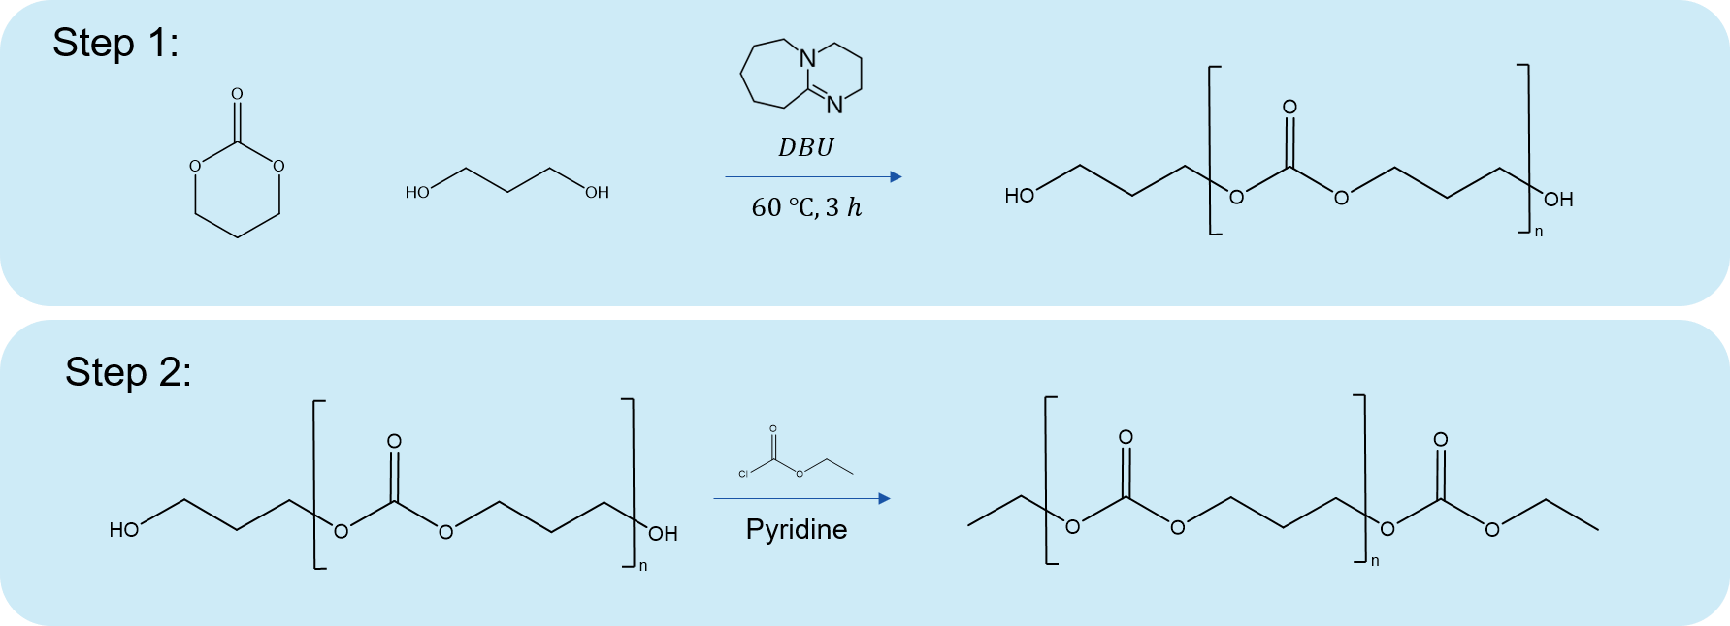**Synthesis of oligomers:**

**Figure S1:** Synthesis route for end-capped carbonate oligomers. The dimers (O1) were synthesised in one step by simply using 1,3-propanediol as the reactant in step 2.

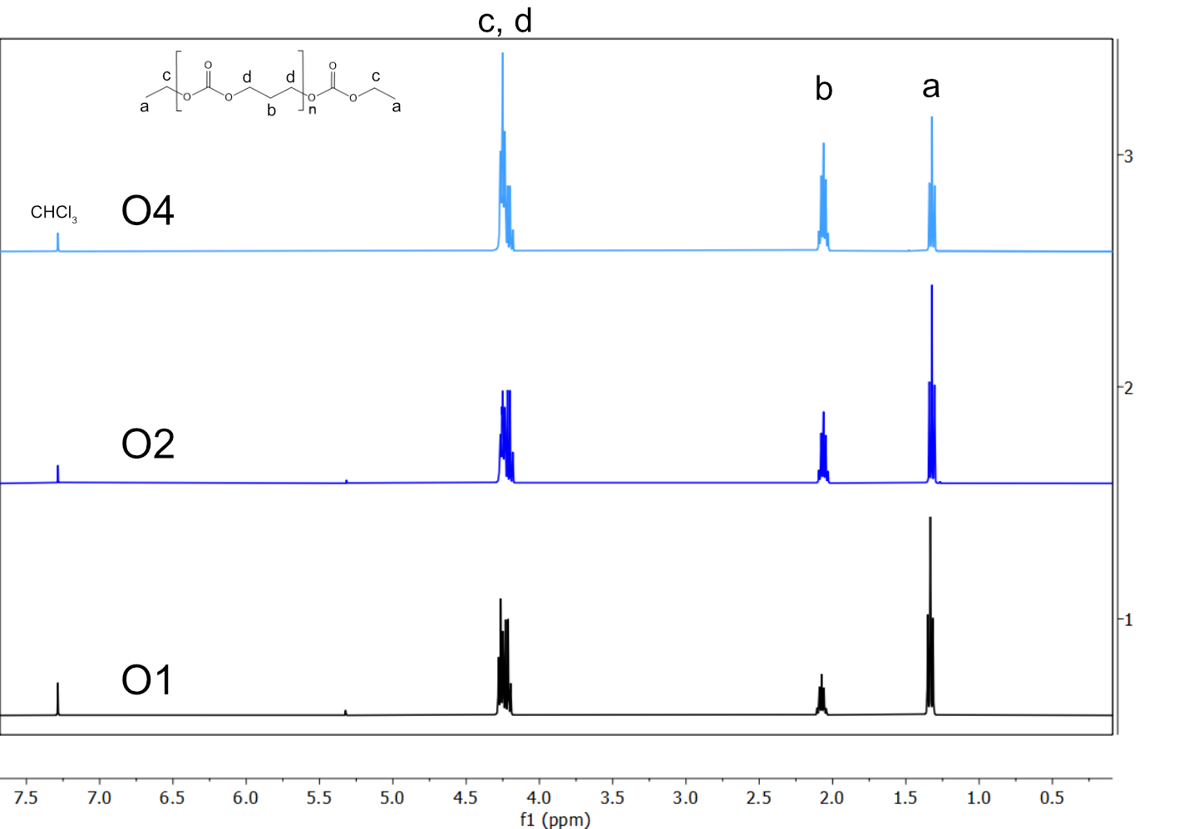

**Figure S2: H1-NMR spectra of synthesised oligomers. Deuterated chloroform was used as the solvent.**

**Table S1: Intensities and calculated repeating units from 1H NMR spectra.**

|  |  |  |  |
| --- | --- | --- | --- |
| **Sample** | **Intensity (*a*)** | **Intensity (*b*)** | ***n* (=3×*b*/*a*)** |
| **O4** | **1** | **1.3** | **3.9** |
| **O2** | **1** | **0.67** | **2** |
| **O1** | **1** | **0.33** | **0.99** |

**The average number of repeating units (*n*) can be obtained from taking the ratio of the intensities of a peak from the repeating unit (*b*) and one from the end group (*a*). The ratio is multiplied by 3 to account for the number of protons for each peak.**

**Synthesis of oligomeric SBEs:**

**Table S2:** Calculated Hansen Solubility parameters for oligomers and monomer.

|  |  |  |  |  |  |
| --- | --- | --- | --- | --- | --- |
| Molecule | *M*n (g/mol) | *δ*D | *δ*P | *δ*H | *δ*Tot |
| Bisphenol A ethoxylate dimethacrylate | 540 | 17.8 | 3.2 | 4.3 | 18.6 |
| O4 | 526 | 14.9 | 9.6 | 7.0 | 17.6 |
| O2 | 322 | 15.5 | 9.1 | 6.2 | 19.0 |
| O1 | 220 | 15.8 | 8.6 | 6.0 | 18.9 |

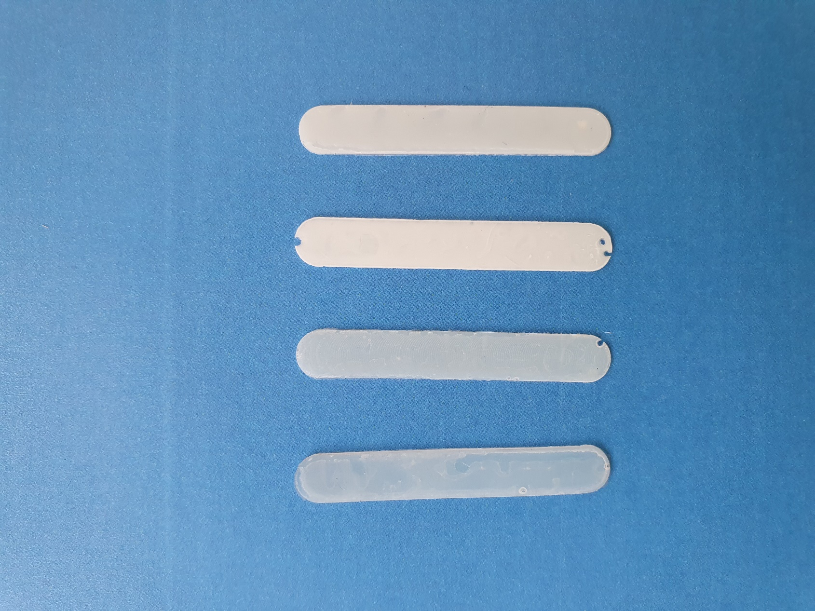**Figure S3:** FTIR spectra of O1_50% before and after curing. The boxed region represents the vinyl stretching peak at 1637 cm-1.

**Photos of films**

**Figure S4:** Cured SBE films containing oligomeric liquid electrolyte. From left: O1_40%, O2_40%, O4_40%, O1_50%.

**Figure S5:** Cured SBE films with formulation: O1_40%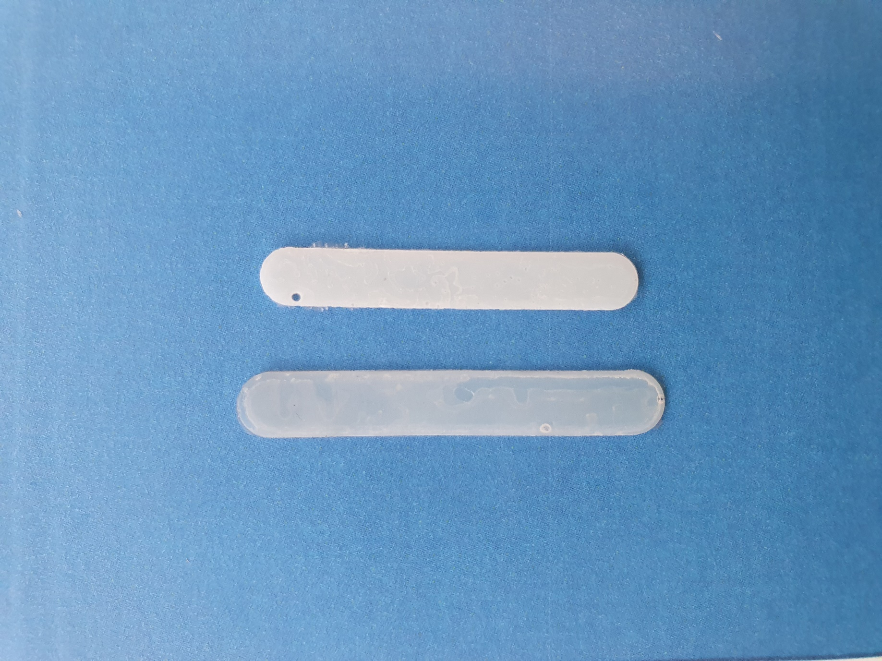. Top: dried film after solvent extraction in DMC. Bottom: Wet film stored after curing. The drying process leads to significant shrinkage of the film, which is visible in the figure above.

**FE-SEM micrographs**

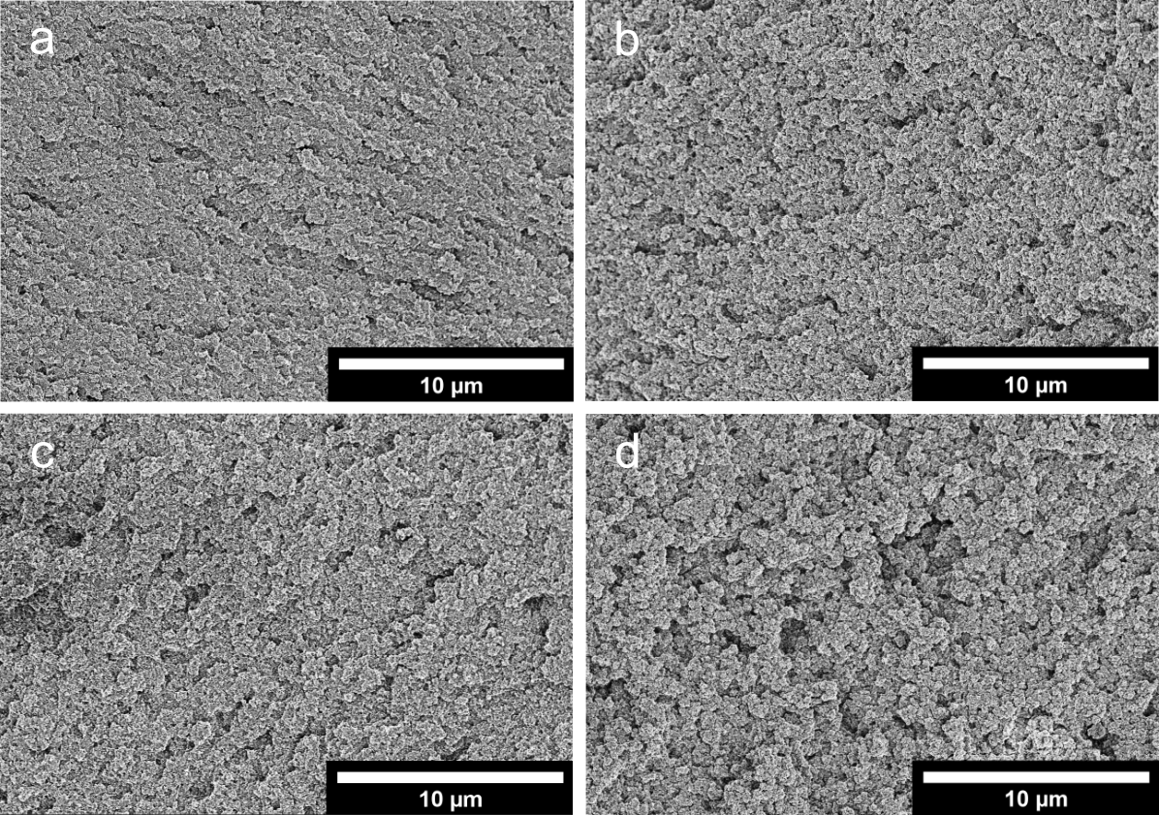

**Figure S6**: FE-SEM micrographs at lower magnification of the cross-section of a) O1_40%, b) O1_50%, c) O2_40%, and d) O4_40% after drying.

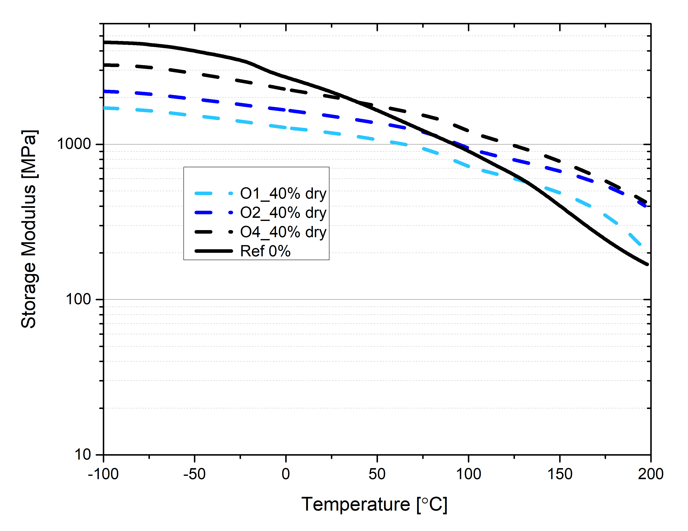**DMA curves of SBE films**

**Figure S7:** DMA curve of oligomeric SBEs in dry condition and a reference film.

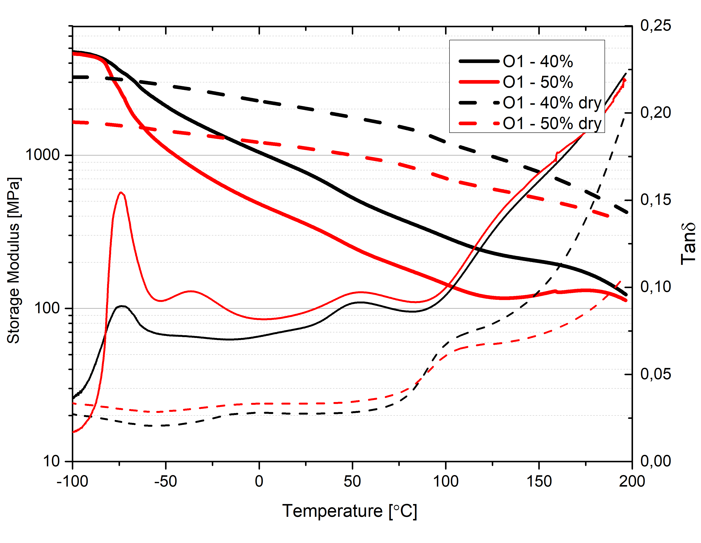A reference film was synthesised using only the monomer. A small amount of acetone (<10 wt%) was used to dissolve 1 wt% AIBN, and left to evaporate in a fume hood. The films were cured at 90 °C for 1 h.

**Figure S8:** DMA curve of O1-40% vs. O1-50% in both wet and dry condition.

**Conductivity of SBE films:**

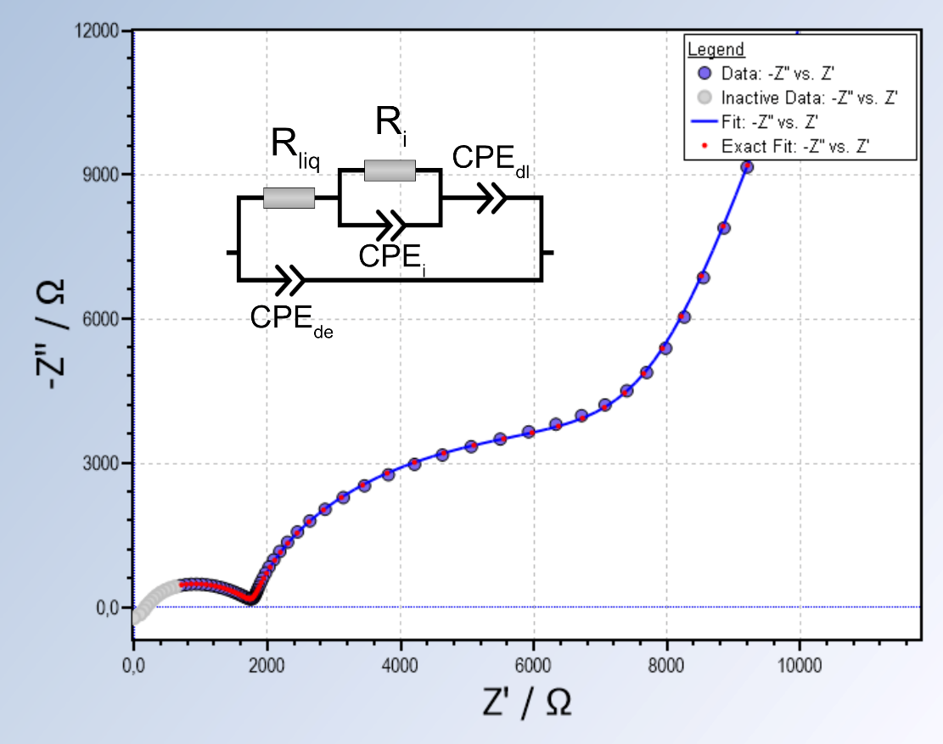For O4_40% and O2_40%, the Nyquist plots generally displayed an initial semicircle at high frequencies, followed by a partial half- semicircle at low frequencies. *R*liq and *R*i could be extracted from applying an equivalent circuit containing constant phase elements (CPE) for the dielectric capacitance (*CPE*de), the interface (*CPE*i), and the double layer (*CPE*dl). Due to the low resistance of the oligomeric carbonate electrolyte O1, the response from *CPE*de is pushed to frequencies above what could be measured by the instrument and is not seen in the Nyquist plot. Thus, a simpler equivalent circuit was used to extract the resistances.

**Figure S9:** Exemplary Nyquist plot and data fit for the applied equivalent circuit. All measurements of O4_40% and O2_40% were fitted using the circuit in the figure. Sample in figure: O2_40% at 25 °C.

**Figure S10:** Exemplary Nyquist plot and data fit for the applied equivalent circuit. All measurements of O1_40% and O1_50% were fitted using the circuit in the figure. Sample in figure: O1_40% at 25 °C.

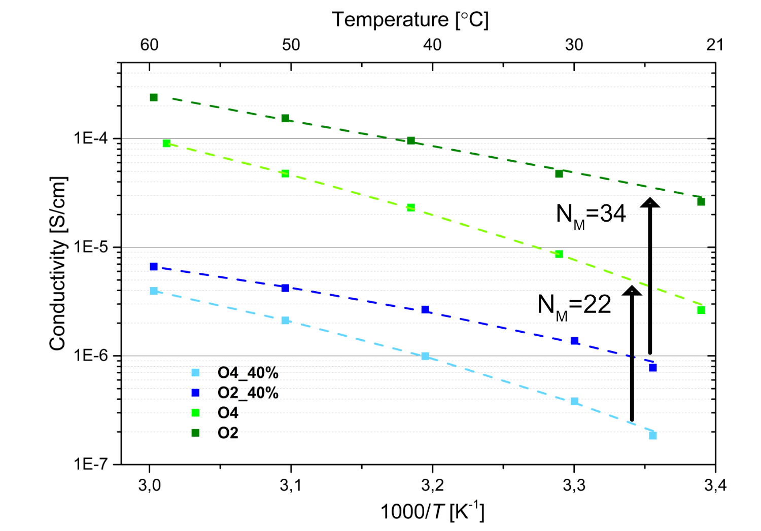

**Figure S11**: Conductivity vs. temperature for pure O2 and O4 and SBEs.*N*M represents the MacMullin number. Dashed lines refer to the VFT fits that have been applied to the data.

Table S3: VFT parameters calculated by applying equation S1 to conductivity data.

|  |  |  |  |
| --- | --- | --- | --- |
| Sample | *A* | *E*a | *T*0 |
| O1_50% | 4.9×10-4 | 1994 | 223 |
| O1_40% | 9.4×10-5 | 890 | 260 |
| O2_40% | 3.8×10-4 | 3544 | 228 |
| O4_40% | 1.3×10-3 | 4968 | 230 |
| O1 | 0.1 | 8233 | 130 |
| O2 | 1.6 | 14468 | 136 |
| O4 | 0.4 | 8992 | 204 |

$σ=A*exp⁡(\frac{-E_{a}}{R(T-T_{0}})$ (S1)